IdeationPhase

DefinetheProblemStatements

|  |  |
| --- | --- |
| Date | 19June2025 |
| TeamID | LTVIP2025TMID60646 |
| ProjectName | VisualizlingHouseMarketTrends:AnAnalysisof Sale Prices And Feactures using Tableau |
| MaximumMarks | 2Marks |

**CustomerProblemStatementTemplate:**

Create a problem statement to understand your customer's point of view. The Customer Problem Statement template helpsyoufocusonwhatmatterstocreateexperiencespeoplewill love.

A well-articulated customer problem statement allows you and your team to find the ideal solution for the challenges your customers face. Throughout the process, you’ll also be ableto empathize with your customers, which helps you better understand how they perceive your product or service.

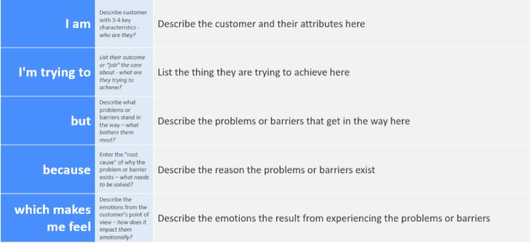

Examples:

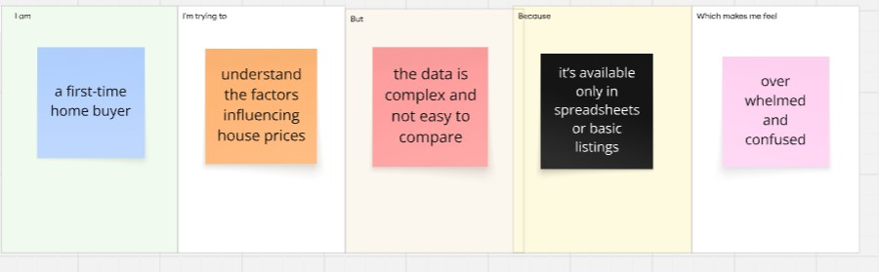

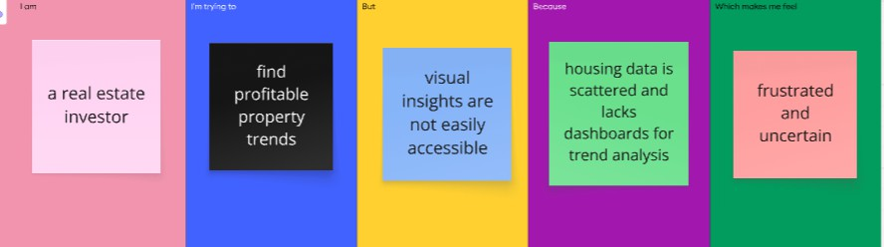

|  |  |  |  |  |  |
| --- | --- | --- | --- | --- | --- |
| **Problem**  **Statement(PS)** | **I am (Customer)** | **I’mtryingto** | **But** | **Because** | **Whichmakesmefeel** |
| PS-1 | a  first-time home buyer | understand the factors influencing houseprices | the data is complex and not easy to compare | it’s available only in spreadshe ets or basic listings | overwhelmedand confused |

|  |  |  |  |  |  |
| --- | --- | --- | --- | --- | --- |
| PS-2 | arealestate investor | find profitable property trends | visual insights arenot easily accessi ble | housingdata is scattered and lacks dashboards for trend analysis | housing data is scattered and lacks dashboardsfortrend analysis |